- Volume 2  - Issue 1  January 23, 2024 | WOMEN OF THE SWIFT FLOWING RIVER CULTURAL NETWORK (WSFR)
A STRONG WOMAN IS ONE WHO BECOMES THE CHANGE SHE WANTS TO SEE IN THE WORLD | WSFR was incorporated in January 2021 and meet our Board of Directors: Linda Campbell is president, Nancy Roy is our Treasurer, Dora Durocher is our elder, Stephanie Wapamoose secretary, Rebekka Renneberg is our youth representative. Angie Campbell heads up the ISET program, Nola Wuttunee is in Media and Communications, Marie Lavallee provides administration support and Darlene Kaminski is our Accountant.  VISION  WSFR aspires to improve the lives of Indigenous women and their families in Saskatchewan now and for future generations.  MISSION  We provide culturally sensitive support by raising awareness of issues that concern Indigenous women, providing advocacy for women to our national body NWAC Native Women’s Association of Canada, offering mentoring to our members regarding business or education, facilitating networking with other members, and offering outreach, job training and education for Indigenous and gender diverse women and their families in Saskatchewan.  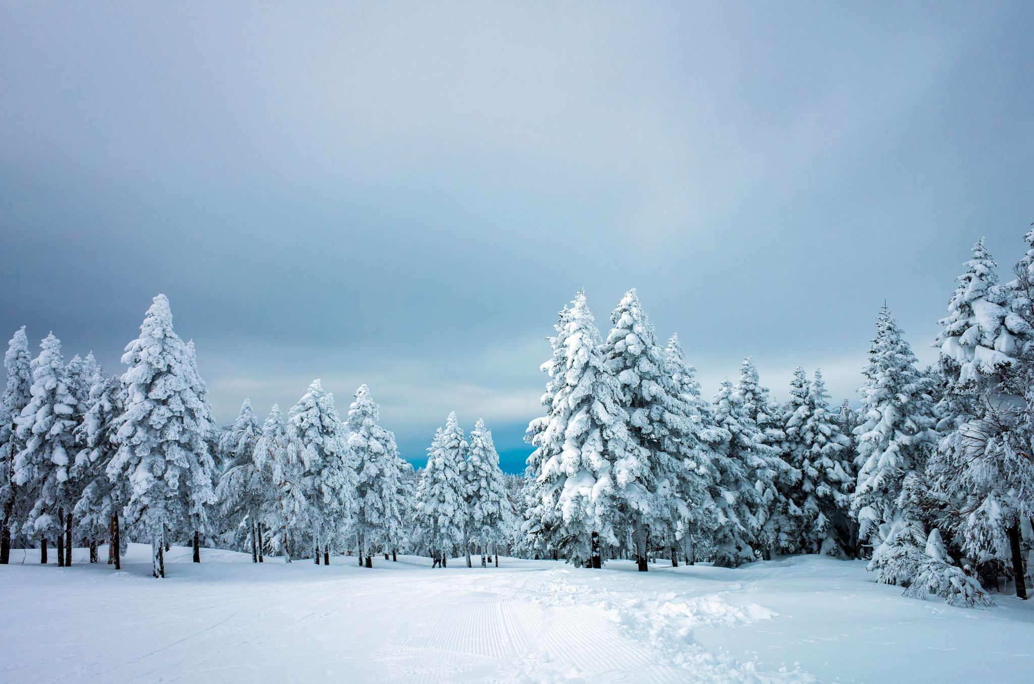
WHO WE ARE | NWAC PTMA  We are a PTMA (Provincial and Territorial Member Association), an affiliate of NWAC (Native Women’s Association of Canada), and we work to serve our membership.  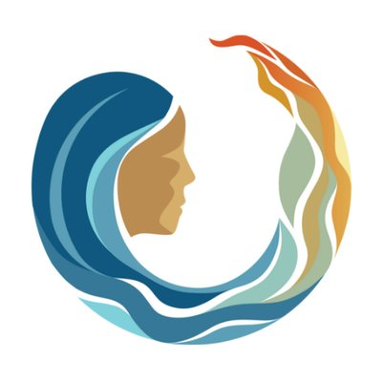
MEMBERSHIP  SASKATCHEWAN | We have over 50 members who have joined us and we ask that you invite your sisters, mothers, aunties and grandmothers to join us!  We would love to hear from you about what your needs are as we move into a new year and what you are looking for from us! Please get in touch at info@wsfr-sk.org.  ACTIVITIES, MEETINGS, PROJECTS, AND PLANNING IN PAST FEW MONTHS *AT A GLANCE *  - WSFR President Linda Campbell, Rebekka Renneberg, Dora Durocher and Nancy Roy attended the NWAC Annual General Assembly.  - Honouring Our Children campout was held in La Plonge to honour the children who were laid to rest there.  - The WSFR President attended a Capacity Building workshop at the head offices of NWAC in Ottawa to learn about capacity building and governance.  ISET  - The ISET Program began in March 2023, and provides funding to design and deliver training services to women in their communities. 10 women have been funded so far since the start of the program. Out of that group, 9 women completed their programs, and 1 woman just started her training as an LPN in the Indigenous Practical Nursing program.  - The demand for funding is great as we have 63 women on the wait list, and we hope we can have the funds to assist all.  - ISET’s Angie Campbell assisted with some online classes through NWAC and 3 women who applied are currently taking classes in the People Skills Essential Program, Administrative Assistant Program, and the Office Tech Essentials Course.  MAID – Medical Assistance in Dying  - Discussion was held online with members of WSFR on the MAID program (Medical Assistance in Dying). It is a heavy topic which was held with respect of the issue that faces people in today’s world. This information will go to inform NWAC’s work in this area.  MMIWGS2+  - According to the Native Women’s Association of Canada (NWAC), Saskatchewan Indigenous women, girls and gender-diverse people continue to be at risk to go missing or be murdered. Our women are more likely to be killed by a stranger, but the partners of these women or people well known to them often commit this crime as well.  - Most cases involve young Indigenous women and girls and gender-diverse people who are under the age of 31. Where the information is known, 96% of missing and murdered women are mothers.  - More than 70% of murders often occur in urban areas such as Regina and Saskatoon and there are also a greater number of disappearances occurring on-reserve than the rest of Canada.  - In 2022-2023, NWAC developed the Safe Passage website found at https://safe-passage.ca/ which has grown to include a trauma-informed, community-driven and a survivor-centred initiative. There is also research and educational tools that have been developed and culturally relevant support and care.  - The updated website honours the voices and stories of MMIWG2S+’s families and survivors through the Safe Passage’s stories page, to commemorate and honour the missing and murdered women and girls and gender-diverse people.  - NWAC established the Indigenous Women’s Safety Council in 2023 and meets on a regular basis to ensure the council is at the centre of our efforts to end genocide. The council is made up of 18 members from our provincial and territorial member associations.  - The council was created to gather perspectives, invaluable knowledge and expertise of grassroots Indigenous women’s organizations. It shares knowledge, ideas and concerns on areas where they feel unsafe, and ensure they can access all necessary community resources and supports.  - The Metis Nation – Saskatchewan has a Metis-specific service for families of MMIWG2S+ and provides Metis-specific trauma supports and will help in obtaining information from public agencies such as police services and the coroner’s office, that may have information about a loved one or incident.  They have a national toll-free crisis line to provide mental health supports that related to missing and murdered Indigenous people. If you require assistance, call: 1-844-413-6649.  Please go to https://safe-passage.ca/ for more information regarding the work the Native Women’s Association of Canada is doing to ending the ongoing MMIWG2A+ genocide.  Reclaiming Power and Place: The Final Report of the National Inquiry into Missing and Murdered Indigenous Women and Girls https://www.mmiwg-ffada.ca/  The Assembly of First Nations efforts in advocacy for meaningful action to end violence against MMIWG2A+: https://afn.ca/rights-justice/murdered-missing-indigenous-women-girls/  Facebook links to MMIW&G awareness: https://www.facebook.com/groups/948954091969806  https://www.facebook.com/groups/302418585027779  https://www.facebook.com/groups/2177185985746068  We welcome all new members and for further information, please contact us at: info@wsfr-sk.org  You can also find us at our website: www.wsfr-sk-org and on Facebook at Women of the Swift Flowing River to follow regular updates on job opportunities and events!

