Volume1/Issue 3  MARCH 31, 2023 | WOMEN OF THE SWIFT FLOWING RIVER CNI
When Women support each other, incredible things happen. | VISION  WSFR-CNI aspires to improve the lives of Indigenous women and their families now and for future generations.  MISSION  To provide culturally sensitive support and direct service delivery by raising awareness, advocacy, mentoring, networking, outreach and education for Indigenous and gender diverse women and their families.  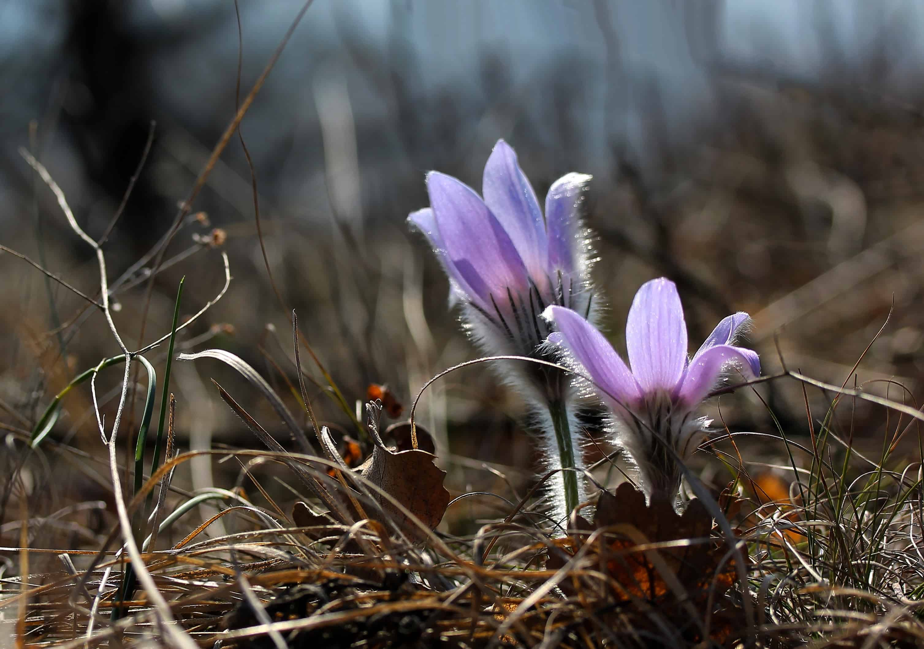
WHO WE ARE | NWAC PTMA  WSFR (Women of the Swift Flowing River CNI) is a new PTMA (Provincial and Territorial Member Association), which is an affiliate of NWAC (Native Women’s Association of Canada). For more information of NWAC, visit website www.nwac.ca
MEMBERSHIP  SASKATCHEWAN | The Membership Drive occurred at Saskatoon, Beauval, La Ronge and Yorkton during the months of January, February and March where women were invited to listen to the presentation of President Linda Campbell on the new organization WSFR and how women can join the group and be a member. Women were asked to share their views about their goals and aspirations and wish list on what it is they wanted in their communities.  After comparing the wish list of women from four communities (35 women total), a compilation list was drafted up on what women identified as their main priorities of needs as women in their communities.  The priorities identified are listed in numerical order of importance to them are:  1)- Land based healing/ cultural camps/wellness workshops/ residential school talks/ teachings/ elders to help  2)- Women and Youth activities together / support groups/ mingling/ reconnections  3)- Employment and Training and Ec Dev  4)-Supports for Young moms/ Prenatal care  5)-MMIWG- want to be more involved in activities  6)- Mental Health supports- grief/loss/anger management workshops  7)- needing elders to remain in communities instead of being removed to other facilities out of town  ACTIVITIES, MEETINGS, PROJECTS AND PLANNING IN FEBRUARY AND MARCH 2023  - WSFR President had attended a virtual meeting of Indigenous leaders and representatives, Government of Canada Ministers, and Provincial and Territorial Ministers in January to discuss the development of a collaborative approach to better address the tragedy of Missing and Murdered Indigenous women, girls (MMIWG) and 2SLGBTQQIA+ people.  - The outcome of this meeting was successful as WSFR will be organizing an advocacy team meeting with a group in Saskatoon in April 2023  - The ISET Program will commence on April 3, 2023 and a callout will be sent out to members to assist in the financial aspect of their educational programs. The ISET Program provides funding to indigenous service delivery organizations that design and deliver training services to women in their communities. An ISET Co-ordinator was hired to carry out program.  - An employment opportunity was secured and posted on Facebook and our website. Details are provided below. The job includes an Administrative Assistant to the President.  - A Climate Change virtual engagement session was scheduled on March 8 where 16 women had a discussion on the impacts of climate change in their regions and communities. Discussions included talks on the issues affecting human health and diseases as well as the environmental health and the impact by the effects of greenhouse gas emissions and climate change.  - One of the future projects we hope to have is to develop a ‘Resiliency Lodge’ which will have a physical building on a selected land base where women and girls and gender-diverse people can gather on many different purposes and planning or healing initiatives.  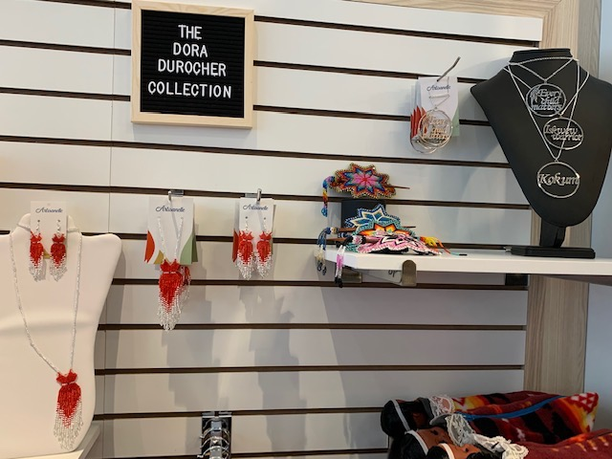  Displayed at the NWAC Store ‘Artisanelle’  Board member Dora Durocher encouraged women to set up their own business opportunity with NWAC within their store in Ottawa, ON. She has set up her own space to show how it can be done. Congratulations, Dora!!

Employment Opportunities
-will be posted here as opportunities arise.

We welcome all new members and for further information, please contact us through our website at:

www.wsfr-sk.org

or email us at:

womensfr@icloud.com

WSFR CNI
SASKATCHEWAN

