- Volume 1/ Issue 2  FEBRUARY 28,2023 | WOMEN OF THE SWIFT FLOWING RIVER CNI
When Women support each other, incredible things happen. | The organization was incorporated after a new Board of Directors were selected. The Board of Directors includes 7 Board Members representative of regional areas and which includes an Elder and a Youth member and 2SLGBTQQ1A+ women in Saskatchewan.  VISION  WSFR-CNI aspires to improve the lives of Indigenous women and their families now and for future generations.  MISSION  To provide culturally sensitive support and direct service delivery by raising awareness, advocacy, mentoring, networking, outreach and education for Indigenous and gender diverse women and their families.  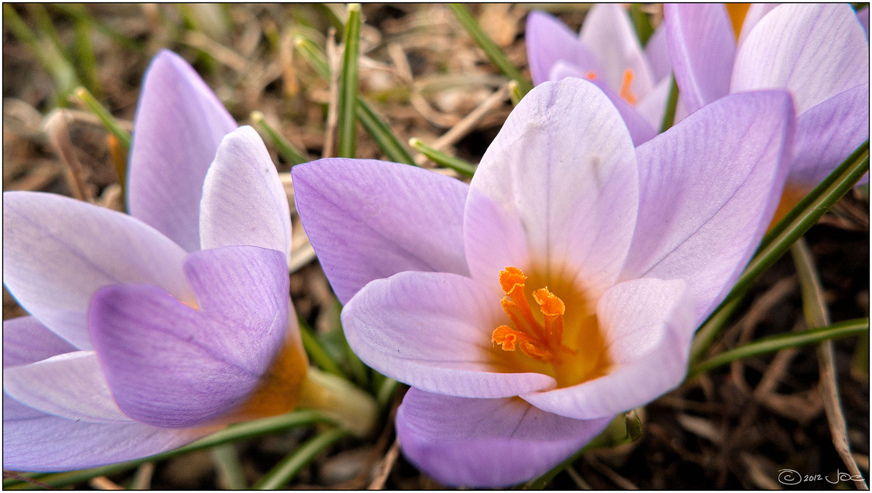
WHO WE ARE | NWAC PTMA  In its new status as a PTMA (Provincial and Territorial Member Association), an affiliate of NWAC (Native Women’s Association of Canada), work commenced immediately in order to reach some of our goals and to serve the membership.
MEMBERSHIP  SASKATCHEWAN | The Membership Drive occurred at Saskatoon, Beauval and La Ronge during the month of February 2023. The March drive is planned in Yorkton for Wednesday, March 9, 2023.  ACTIVITIES, MEETINGS, PROJECTS AND PLANNING IN FEBRUARY AND MARCH 2023  - WSFR President had attended a virtual meeting of Indigenous leaders and representatives, Government of Canada Ministers, and Provincial and Territorial Ministers in January to discuss the development of a collaborative approach to better address the tragedy of Missing and Murdered Indigenous women, girls (MMIWG) and 2SLGBTQQIA+ people.  - The outcome of this meeting was successful as WSFR will be organizing an advocacy team meeting with a group in Saskatoon in April 2023  - The ISET Program will commence on April 1, 2023 and a callout will be sent out to members to assist in the financial aspect of their educational programs. The ISET Program provides funding to indigenous service delivery organizations that design and deliver training services to women in their communities.  - A Capacity Building Manager was hired on a contract basis for 3 months to assist in the administrative support to the President.  - Two more employment opportunities were secured and posted on Facebook and our website. Details are provided below. The jobs include an Administrative Assistant to the President and the ISET Co-ordinator position.  - A Climate Change forum on zoom will be scheduled for March 8 where 20 women will gather to have a discussion on the impacts of climate change in their regions and communities. They will discuss the issues affecting human health and diseases as well as the environmental health and the impact by the effects of greenhouse gas emissions and climate change.  - One of the future projects we hope to have is to develop a ‘Resiliency Lodge’ which will have a physical building on a selected land base where women and girls and gender-diverse people can gather on many different purposes and planning or healing initiatives.

Employment Opportunities

CAREER OPPORTUNITY
Time Sensitive ~ Apply by MARCH 10, 2023 – Extended to March 17,2023
ADMINISTRATIVE ASSSISTANT to the PRESIDENT Saskatoon Provincial Office About Women of the Swift Flowing River Cultural Network Incorporated (WSFR-CNI)
WSFR-CNI is the Provincial/Territorial Membership Association (PTMA) of the Native Women’s Association of Canada (NWAC). Go to www.wsfr-sk.org for more information.
Administrative Assistant to the President
The Administrative Assistant provides office and administrative support to the WSFR President and involves both government and grassroots interactions.
Full Time (40 hours/week; $21.00 – $23.00/hour)
This is a hybrid term position effective immediately to June 30, 2023 with potential for extension. It has a flexible work week with some evening and weekend work and some travel.
Key duties include working collaboratively with the President to:
- • Prepare and update the President’s monthly calendar
- • Schedule meetings at the grassroots, government and corporate levels
- • Plan and organizing regular Board and Committee meetings
- • Prepare purchase orders and expense claims
- • Prepare and submit reports to the funders
- • Oversee and manage the Membership list
- • Produce a monthly newsletter plus other relevant duties.
Minimum Qualifications:
- Post-secondary education in Business Administration or equivalent
- Excels with note taking and writing briefing notes
- Clear Child Abuse and Criminal Records Check
- Valid Driver’s License.
Knowledge and Skills:
- Direct experience working with Indigenous women’s advocacy organizations
- Understands the issues and understands how the provincial government works
- Full comprehension, knowledge and experience with all computer software including
Microsoft suite of tools and internet techniques
Please submit resume, cover letter and 3 references in confidence by MARCH 10 to:
WSFR Human Resources Committee CODE PAATerm2023
Email: invisioningwomensk2022@gmail.com Email submissions only.

We welcome all new members and for further information, please contact us through our website at:

www.wsfr-sk.org

or email us at:

womensfr@icloud.com

WSFR CNI
SASKATCHEWAN

