- Volume 1 | Issue 1  January 23, 2023 | WOMEN OF THE SWIFT FLOWING RIVER CNL
A STRONG WOMAN IS ONE WHO FEELS DEEPLY AND LOVES FIERCELY | The organization was incorporated in January 2021 after new Board of Directors were selected on October 20, 2022. The Board of Directors includes 7 Board Members representative of regional areas and which includes an Elder and a Youth member and 2SLGBTQQ1A+ women in Saskatchewan.  VISION  WSFR-CNI aspires to improve the lives of Indigenous women and their families now and for future generations.  MISSION  To provide culturally-sensitive support and direct service delivery by raising awareness, advocacy, mentoring, networking, outreach and education for Indigenous and gender diverse women and their families.  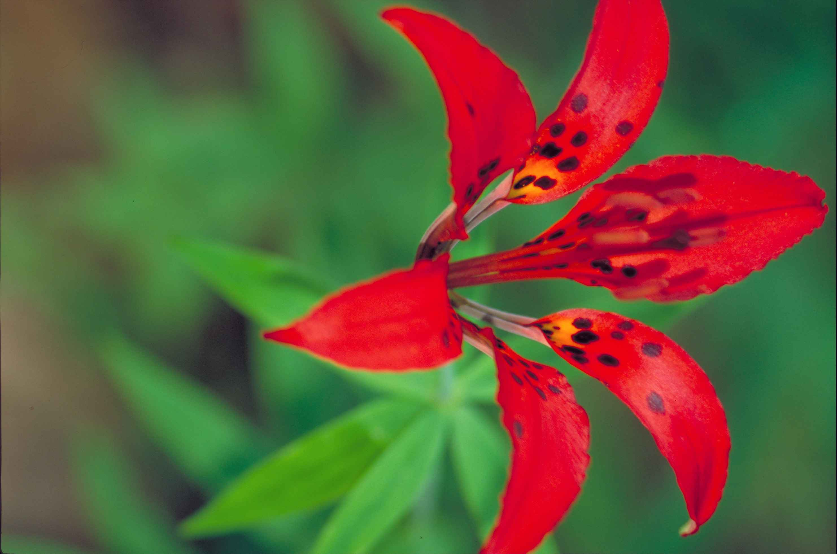
WHO WE ARE | NWAC PTMA  In its new status as a PTMA (Provincial and Territorial Member Association), an affiliate of NWAC (Native Women’s Association of Canada), work commenced immediately in order to reach some of our goals and to serve the membership.  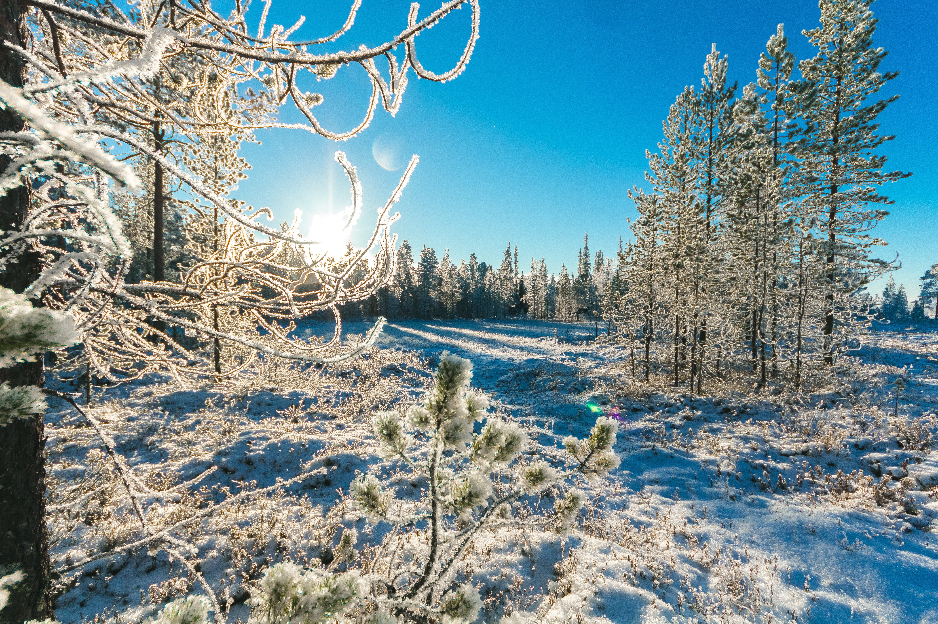
MEMBERSHIP  SASKATCHEWAN | The Membership Drive has started and will be visiting some communities across the province as well as relaying information through our website www.wsfr-sk.org and a Facebook has also been created for women’s access.  This is a call to all women and girls and gender-diverse people in Saskatchewan inclusive of First Nations on and off reserve, status and Non-Status, Metis and Inuit to be given the opportunity to participate in activities and events and to be part of the organization.  Another goal we have is to build affiliates across Saskatchewan in order to improve service delivery and strengthen communications on shared programming and how we can offer services together.  ACTIVITIES, MEETINGS, PROJECTS AND PLANNING IN PAST FEW MONTHS *AT A GLANCE *  - WSFR President attended the NWAC Board Meeting and NWAC Strategic Planning Meeting in November 19 & 20, 2022 in Ottawa ON. They worked on setting up goals in building a strong, resilient organization through internal capacity building, identified key issues relevant to Indigenous women and their families as well as increasing communication and resource capacity as a PTMA.  - WSFR President attended a virtual meeting of Indigenous leaders and representatives, Government of Canada Ministers, and Provincial and Territorial Ministers. The purpose of this meeting was to advance the development of a collaborative, co-ordinated approach to better address the tragedy of Missing and Murdered Indigenous women, girls (MMIWG) and 2SLGBTQQIA+ people.  - As one of the first projects, two ‘Sisters-in-Spirit’ Vigils were held in October 2022, the first one at ERFN La Plonge and the other in Yorkton. Both community sessions were community-driven and honoured our stolen loved ones and educated and informed the public as well.  - The ISET Program will commence on March 2023, and a callout will be sent out to members to assist in the financial aspect of their educational programs. The ISET Program provides funding to indigenous service delivery organizations that design and deliver training services to women in their communities.  - A Capacity Building Manager was hired on a contract basis for 3 months to assist in the administrative support to the President, and complete networking strategies, assisting in work plans, organizing board meeting and all duties pertaining to the organization’s fast growing entity.  - One of the future projects we hope to have is to develop a ‘Resiliency Lodge’ which will have a physical building on a selected land base where women and girls and gender-diverse people can gather on many different purposes and planning or healing initiatives.  We welcome all new members and for further information, please contact us at:  info@wsfr-sk.ca  or  womensfr@icloud.com  WSFR CNI  SASKATCHEWAN

