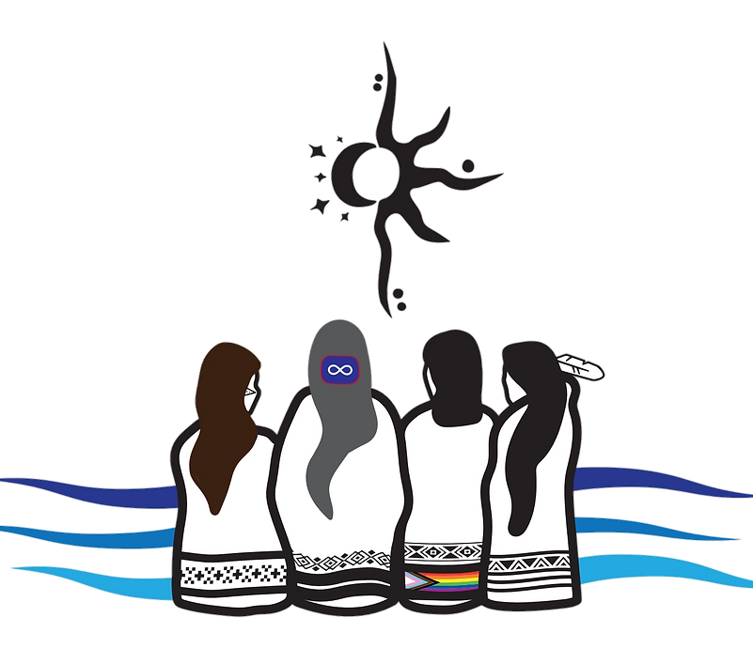

Are you interested in joining an organization that promotes the wellness of Indigenous women, girls, and 2SLGBTQQIA+ women from across Saskatchewan?

Consider applying to join Women of the Swift Flowing River (WSFR) as we expand to include youth specific programming. We are an Indigenous women’s provincial volunteer organization whose vision is to improve the lives of Indigenous women and their families now and for future generations.

But we need your help. We are looking to hire **two** youth representatives between the ages of 15 and 29, who will be a part of the design and guidance of youth-specific programming in the Northern and Southern regions of Saskatchewan. You have an idea for workshops or learning opportunities that would be helpful for your region – this is a way that you can see that idea come to life.

Eligibility:

* Between the ages of 15 and 29
* Indigenous women, trans-gender, Two-Spirited or gender diverse individuals
* Identify as First Nations, non-status First Nations, Metis, or Inuit
* Available for weekly meetings with the youth coordinator and youth board member
* From a treaty area within Saskatchewan

Benefits:

* Compensation rate of $15/hour
* Part-time work, ideally suited for students or those looking to supplement income
* Tax free employment for those located on reserve
* Flexible and remote schedule
* Opportunity to see your ideas come to life

If you are interested, please send a resume and cover letter to the youth coordinator at: [jasmynohh@google.com](mailto:jasmynohh@live.com) before 12:00 pm on Wednesday, November 20, 2024. Please see attached job description for more information.

**Job title**: Regional Youth Representative (North/South)

**Company description:** We are Women of the Swift Flowing River (WSFR). We are an Indigenous women’s provincial volunteer organization whose vision is to improve the lives of Indigenous women and their families now and for future generations. For more information on our organization, please visit: [www.wsfr-sk.org](http://www.wsfr-sk.org)

**Job Summary:** In collaboration with the youth coordinator and the youth board member, you will utilize your lived experience as a youth in your region and assess the needs of your area. Combining your knowledge and feedback from youth in your region, we will work collaboratively to design and implement programming to further the social, economical, cultural development of Indigenous female-identifying youth across Saskatchewan.

**Responsibilities:**

* Attend weekly virtual meetings with the youth coordinator and youth board member
* Attend monthly meetings with the WSFR board of directors
* Assess needs of youth in your region
* Design programming to support identified needs of youth in your region
* Implement programming to support the identified needs of youth in your region
* Be available to support in-person or virtual youth programming in your region

**Qualifications and Requirements:**

* Between the ages of 15 and 29
* Indigenous women, trans-gender, Two-Spirited or gender diverse individuals
* Identify as First Nations, non-status First Nations, Metis, or Inuit
* Available for meetings with the youth coordinator and youth board member
* From a treaty area within Saskatchewan

**Experience:** Relevant knowledge or education in youth work, community programming, social development, and/or education, is ideal, but those with a willingness to learn are welcome to apply.

**Reporting structure**: Works collaboratively with the youth coordinator and the youth board member.

**Benefits and perks**

* Compensation rate of $15/hour
* Part-time work, ideally suited for student or those looking to supplement income
* Tax free employment for those located on-reserve
* Flexible and remote schedule
* Opportunity to see your ideas come to life

**Application Instructions**

If you are interested, please send a resume and cover letter to the youth coordinator at: [jasmynohh@google.com](mailto:jasmynohh@google.com) before 12:00 pm on Wednesday, November 20, 2024. Please be sure to self-identify in your cover letter.